**The John Deere Pivot –– From Machinery Manufacturer to Smart Technology Provider**

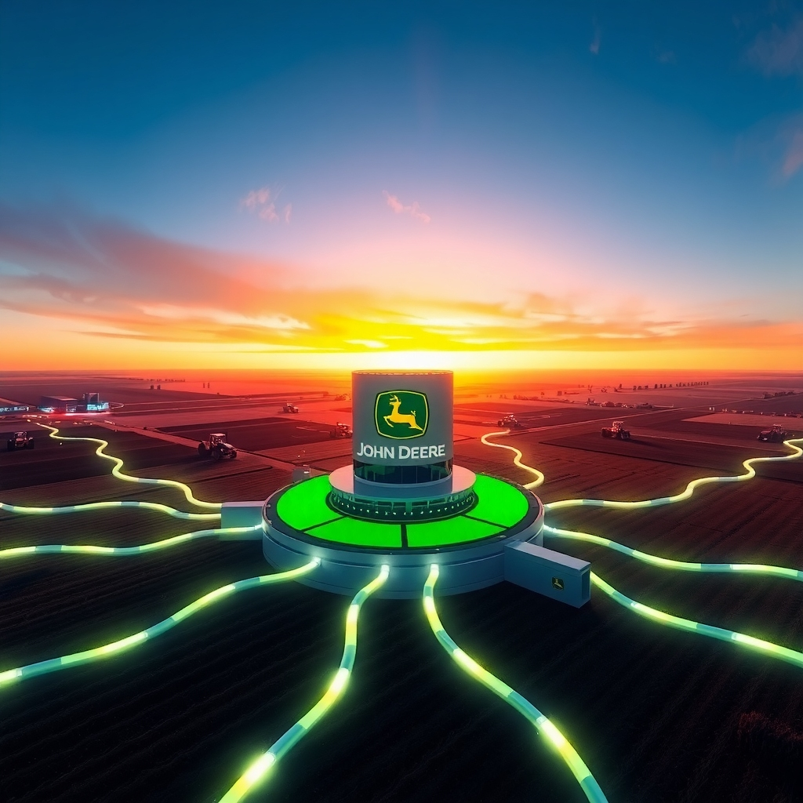

John Deere had long been identified as a leading producer of agricultural machinery. The company identified the growing significance of technology and data in modern agriculture and adjusted its business model accordingly. The company changed its approach to deliver complete agricultural solutions that extend beyond simple machinery and concentrate on enhancing farm efficiency and sustainable productivity.

Key Strategies and Actions:

1. Investing in Precision Agriculture Technologies:
   * GPS and Automation: John Deere took a leading role in the adoption of GPS technology within agricultural machinery to develop automated guidance systems exemplified by AutoTrac™. Farm operations achieve sub-inch precision which minimizes overlap and saves fuel while optimizing input application.
   * Data Collection and Analysis: John Deere created the John Deere Operations Center™ after identifying the importance of farm data. The cloud-based platform provides farmers the ability to monitor and analyze integrated machine data along with field operations and agronomic practices to make informed decisions that enhance yield and profitability.
   * Variable Rate Application: Through its advanced technology that incorporates data analysis and sensor integration John Deere achieves variable rate dispensing of seeds alongside fertilizers and pesticides. This process guarantees that agricultural inputs reach their intended locations in exact required amounts which results in less waste and diminished environmental harm.
   * Machine Learning and AI: John Deere has made substantial investments to integrate machine learning and artificial intelligence capabilities into its product lineup. See & Spray™ technology utilizes cameras alongside AI to identify weeds versus crops so that herbicides can be applied specifically to weeds which leads to minimized herbicide consumption. The company investigates autonomous machines as a strategy to boost operational efficiency and tackle workforce shortages.
2. Developing a Digital Ecosystem:
   * Connectivity: John Deere's JDLink™ telematics system connects machines to enable remote monitoring, diagnostics and data transfer. The system's connectivity enhances fleet management capabilities while minimizing downtime through timely maintenance facilitation.
   * Platform Integration: The Operations Center serves as a central hub, integrating data from various John Deere and even third-party systems. This provides farmers with a holistic view of their operations.
   * Mobile Accessibility: John Deere has developed mobile applications that allow farmers to access critical data and manage their operations from anywhere, at any time.
3. Offering "Solutions as a Service":
   * John Deere is increasingly moving towards a "Solutions as a Service" model. This involves offering technology and data services that allow customers to pay for what they use, lowering upfront costs and aligning John Deere's revenue with the value delivered to the customer.
   * This model also allows for continuous improvement of products and services through ongoing data analysis and software updates.
4. Focusing on Sustainability:
   * John Deere's technology pivot is also heavily focused on promoting sustainable farming practices. Precision application, reduced chemical usage, optimized resource management, and electric/hybrid machinery development all contribute to environmental sustainability while also providing economic benefits to farmers.
5. Organizational and Cultural Transformation:
   * This strategic shift required significant organizational changes within John Deere, including investments in talent with software and data science expertise and fostering a culture of innovation and agility. They have adopted Agile methodologies in their IT and other divisions to improve speed to market and value delivery.

**Impact on Scale, Speed, and Scope:**

* **Scale:** By offering digital solutions, John Deere can scale its impact beyond the number of physical machines sold. Their digital platforms can reach a wider customer base and manage a larger number of connected devices and acres.
* **Speed:** The integration of digital technologies allows for faster data collection, analysis, and decision-making for farmers. Automation and optimized processes also contribute to increased operational speed. Internally, John Deere's adoption of Agile practices has aimed to reduce time to market for new technological solutions.
* **Scope:** John Deere's scope has expanded from being a machinery provider to a comprehensive solutions provider in the agricultural ecosystem. Their offerings now include data analytics, software services, precision agriculture tools, and connectivity solutions, addressing a broader range of customer needs.

**Case Study Examples:**

* **See & Spray™:** This technology allows for targeted herbicide application, reducing herbicide use by up to 90%, leading to significant cost savings and environmental benefits.
* **Operations Center™:** This platform enables farmers to analyze planting data to optimize seeding rates, monitor harvest yields to identify areas for improvement, and track machine performance to minimize downtime.
* **Autonomous Tractor:** John Deere is developing fully autonomous electric tractors, which could revolutionize farming by enabling 24/7 operation and freeing up farmers for more strategic tasks.

**Conclusion:**

John Deere's strategic pivot towards digital agriculture demonstrates a successful transformation of a traditional manufacturing company into a technology-driven solutions provider. By investing in precision agriculture, connectivity, data analytics, and sustainable practices, John Deere has achieved greater scale, improved speed and efficiency for its customers, and expanded its scope within the agricultural industry. This ongoing evolution positions John Deere as a key player in shaping the future of farming